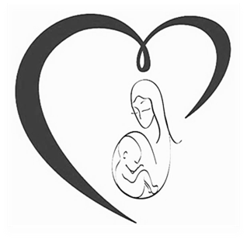
St. Croix OBGYN
O. Anne Treasure M.D., FACOG
Naita Salmon ANP
113 Barren Spot Village Mall, Suite 7
Kingshill VI 00850
Phone: 340-719-9876 Fax: 340773-0600
AUTHORIZATION TO RELEASE MEDICAL RECORDS

Patient Name: ____________________________________________Date of Birth: ________
Address: ___________________________________________________________________________
Phone Number:________________________Email:______________________________________

Person/Organization to Release information:_______________________________________
Street Address: ________________________________________________________________
City______________________ State_______________________ Zip Code_____________
Phone Number___________________________ Fax Number_____________________

Specific Time Of information to be Release:

From_____________ to ___________
Specific Type of Information to be Release:

____ Entered Chart _____ Sonograms____ Labs_______ Billing_____ Progress Notes
The purpose of the Disclosure:

____Continuing Medical Treatment ____ Insurance _____Attorney _____Other

This Release Authorizes the Disclosure of record 90 days from the date of execution. I understand that these records are protected under federal and state law and cannot be disclosed without my written consent unless otherwise provided by law. I further understand that the specific type of information be disclosed may, I further include: Diagnosis, Prognosis, and Treatment for physical illness, including treatment of auto- immune deficiency syndrome (AIDS), AIDS related complex (ARC), Sexual Transmitted Diseases (STDs), or human immunodeficiency virus (HIV).
THERE IS A CHARGE OF $ 1.00 PER PAGE OF THE RECORDS REQUESTED.
I have the right to revoke this consent at any time unless the facility which is to make the disclosure of information has already done.

Patient Signature ______________________________________________ Date ___________
Physician Notification: Approve _____ Yes _____ No Why not? _____________

